**Software Requirements Specification**

**For project e-Furniture**

**Prepared by:**

**Trần Tấn Đạt**

**Lê Hữu Huy**

**Nguyễn Phương Tâm Tâm**

**Vũ Mạnh Khải**

**Lê Đức Nam**

**Trương Minh Hoàng**

**November 11, 2024**

**4. Data Requirements**

**4.1 Logical Data Model**

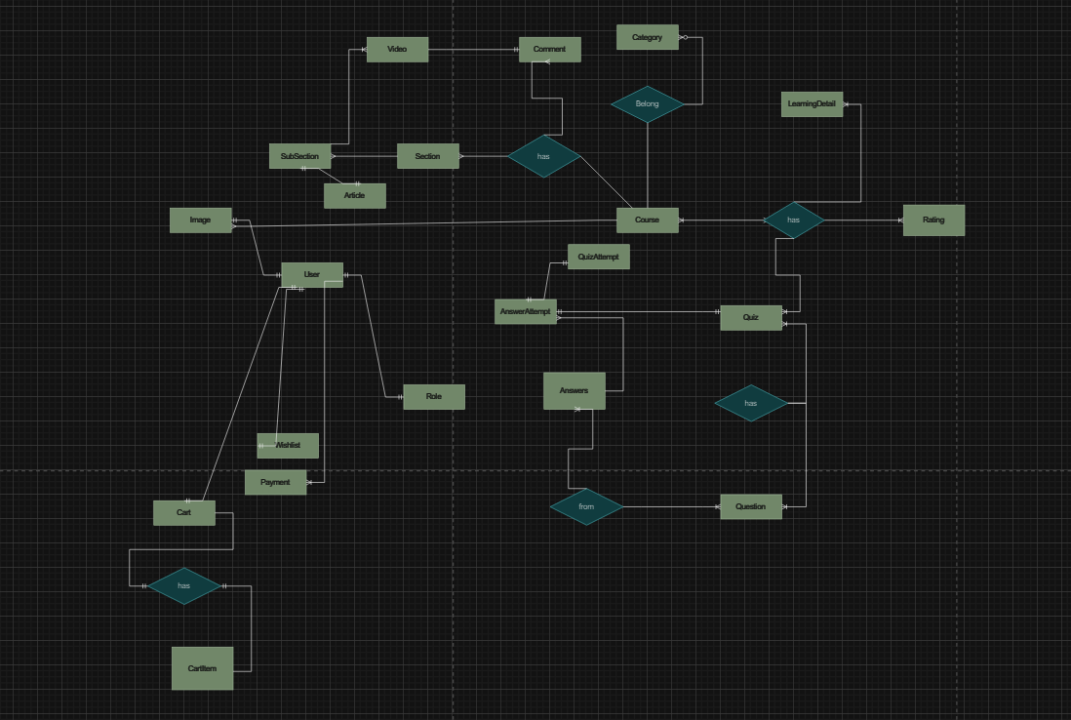

**4.2 Data dictionary**

## 

| **Data Element** | **Description** | **Composition or Data Type** | **Length** | **Values** |
| --- | --- | --- | --- | --- |
| register a course | The "register a course" data element typically refers to information associated with a student's enrollment in a particular academic course.  This data element includes details about the course itself, the student, and any relevant information needed for the registration process | Course Information:  Course Code  Course Title  Instructor  Schedule (day, time, location)  Prerequisites  Credits |  |  |
| create account | Creating an account involves collecting and storing information about an individual or entity to grant access to a system, service, or platform. This data is crucial for personalization, security, and communication purposes. | Personal Information:  -Full Name  -Date of Birth  -Gender  -Address  Contact Information:  -Email Address  -Phone Number  Login Credentials:  -Username  -Password (encrypted) | 50 | Gender: Male, Female, Other  Language: English, Spanish, French, etc. |
| login | Logging in is the process by which a user gains access to a system, service, or platform by providing valid credentials. | Login Credentials:  Username or Email Address  Password | 20 |  |
| userId | Student ID who can view, subscribe, log in, comment | integer | 6 |  |
| course description | A course description is a concise summary of the key aspects of a particular academic course. | Course Title: String  Course Code: Alphanumeric  Instructor(s): String or list of strings  Overview/Summary: String or paragraph | 100 |  |
| course item price | The course item price refers to the monetary cost associated with enrolling in a particular academic course or obtaining specific course-related materials. | numeric, dollars and cents | dd.cc |  |
| create course date | The course creation date is the specific date when an academic course is introduced and officially becomes part of the educational program | date, MM/DD/YYYY | 10 | default = current date if the current time is before the order cutoff time, else the next day; cannot be prior to current date |
| wishlist | A wish list is a collection of items or experiences that an individual expresses a desire to have or achieve | courseId |  |  |
| payment | information about a payment COS accepted for a course | payment amount  + payment method  + transaction number |  |  |
| order cutoff time | the course registration period is a predefined time window when students can sign up for the courses they plan to take during an upcoming academic term or semester. | time, HH:MM | 5 |  |
| course registration period | one menu food item that a Patron requested as part of a meal order | menu food item  + quantity ordered |  |  |
| admin | An admin, short for administrator, is an individual with special privileges and responsibilities related to the control, management, and maintenance of a system, platform, or organization | User Role: String or Enumerated type (e.g., Admin, System Administrator).  Privileges: List of specific permissions or access levels.  Responsibilities: String or list of duties. |  |  |
| admin email | An admin email is the electronic mail address designated for communication related to administrative matters | alphanumeric | 50 |  |
| patron name | name of the employee who placed a meal order | alphabetic | 30 |  |
| payment amount | total price of an order in dollars and cents, calculated per BR-12 | numeric, dollars and cents | dddd.cc |  |
| payment method | how the Patron is paying for a meal he ordered | alphabetic | 16 | payroll deduction, cash, credit card, debit card |
| course management | Course management encompasses the entire lifecycle of a course, from its conception and design to its delivery, assessment, and ongoing improvement. | Course Information: String or structured data.  Enrollment Data: Numeric or Alphanumeric.  Scheduling Information: Date and Time data types.  Grades and Assessments: Numeric or Alphanumeric.  Feedback: String or comments |  |  |
| user management | User management involves the administration and oversight of user accounts within a system. | Usernames/User IDs: Alphanumeric strings or numbers.  Authentication Credentials: Encrypted passwords, biometric data, or other secure means of verifying identity.  Roles/Permissions: Enumerated types or structured data indicating user roles and associated permissions.  User Profiles: String or structured data containing information about each user (e.g., name, contact information). |  |  |

## 